Week 4 Project
ITS1000 Computer and Internet Literacy
Creating a Budget
In this assignment you will create a spreadsheet and a chart to help a hypothetical couple work out their budget. You will submit a Microsoft Excel spreadsheet following the directions below to the appropriate submission folder by the due date. You will name this file W4P_LastName.xlsx.
Please Note: Information to help you with this project is available in the Week 4 online lectures, your textbook, as well as Microsoft Excel Help (F1). Your professor is also a great resource. If you work ahead, you can post questions about this assignment on the Questions for the Professor discussion board and still submit your assignment on time.
Scenario
Tom and Sally were trying to get a handle on their budget. They heard that MS Excel could help them with that. Tom is going to school and has cut back on his hours. Sally has finished her associate’s degree and is working full time. They want to look at the last three months of their income and expenses to see where they can make changes.
Part I – The Spreadsheet
First, in an Excel Spreadsheet, create a budget to show Tom and Sally’s income, expenses, and money leftover each month (Net). Create formulas in your spreadsheet for your calculations using the following data:
- Tom brought home $1,000 a month for January, February, and March.
- Sally brought home $1,900, $2,000, and $1,975 respectively for those three months.
- They paid $1,000 for rent and utilities each month.
- They paid $88 for insurance each month.
- They paid $60 for cell phones and $60 for Internet/TV each month.
- They spent $600, $750 (due to a big birthday bash), and $500 on food respectively.
- Their car payment and gas came to $225, $250, and $300 respectively.
- Entertainment and gifts were $75, $100, and $45 respectively.
- They paid a little extra on their credit card $150, $125, and $100 respectively.
- They allocated $200 each month for personal grooming and health care.
- They put $100 each month into savings.
- Miscellaneous Expenses came to $200, $100, and $400 respectively.
A sample budget layout is included below as an example of one way to lay out a budget.
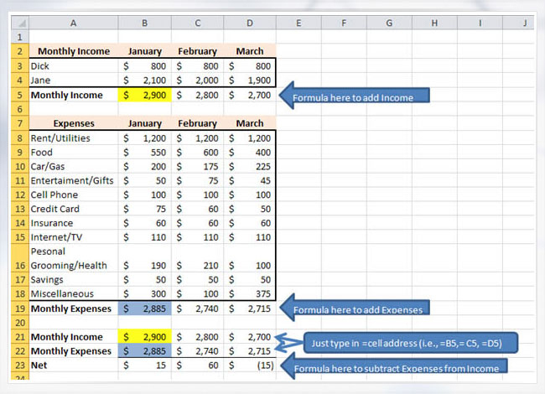
Part II – The Chart
Once you have worked out the budget spreadsheet, use the tabs at the bottom of the page to open another sheet. Here you will create a chart similar to the example below using the tools you learned about in the lectures and the textbook. On the new sheet:
- Create a column chart to visually represent their monthly expenses. If you have a challenge getting the chart on this sheet, research how to move your chart using your reading or Help (F1). You might also try right clicking on the chart.
- Add a descriptive title to the chart.
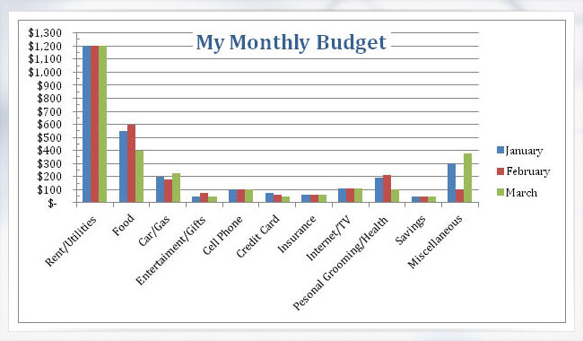
Part III – Changing Values
- Copy everything from Sheet 1 (the budget calculations) and paste it into a new worksheet.
- Change values for Sally’s March income to $200 more. Let's say that they didn't use as much heat in March and their utilities were $75 less (you could use a formula to figure out $75 less but you don’t have to). See how the totals change automatically if you used formulas correctly. If the values did not change, check your formulas and try them again. Seek help if you can’t figure this out.
- Rename each of your three spreadsheets with descriptive names.
By the due date assigned, submit this budget to the Submissions Area. In the message box, share how the process of creating this went for you, including any challenges, successes, or insights.

